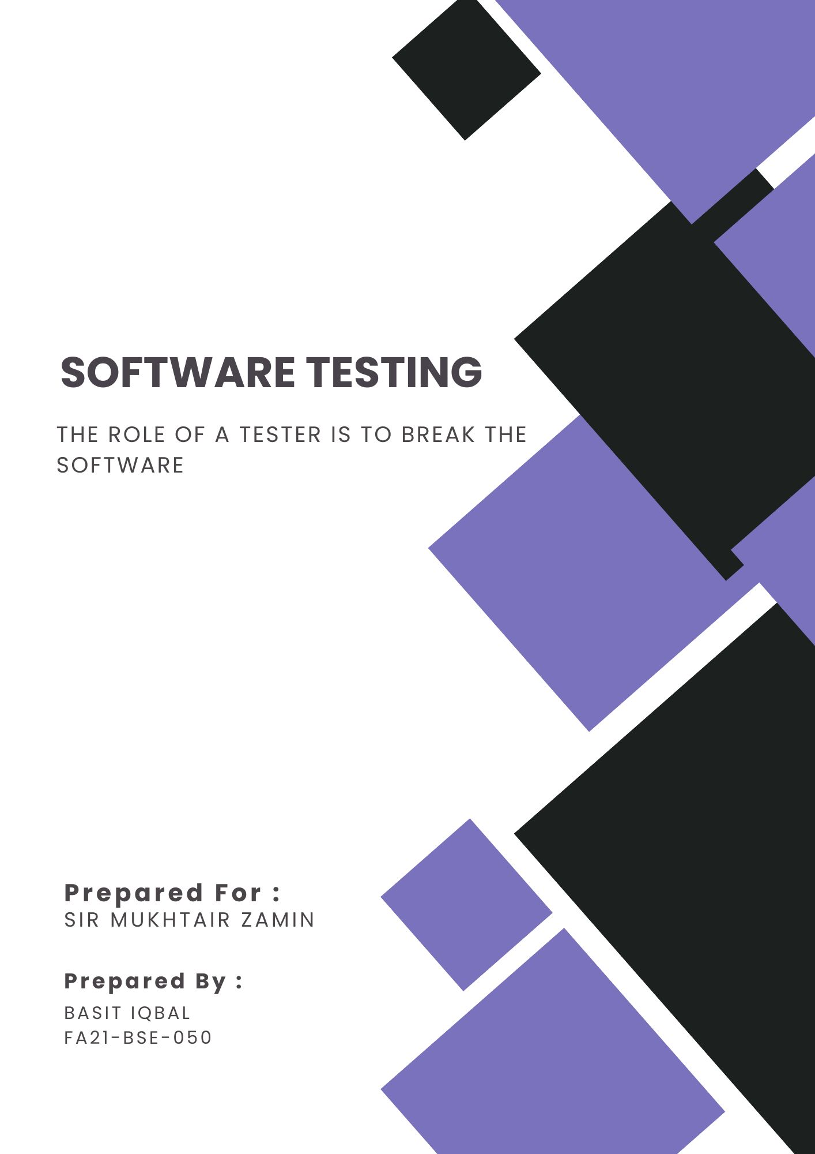

Name: BASIT IQBAL

Reg No: FA21-BSE-050

**Scenario**:

I my case I am doing the testing of the Books LMS. Now here I have made

1. Book
2. Book Repository
3. Book Services
4. IBookRepository.

Now for the Test Folder I have made a tow class:  
1. FakeBookRepository

2. BookServicesTest

I am testing the BookServices Class …. I have implemented Multiple Test cases;

|  |  |  |  |  |  |
| --- | --- | --- | --- | --- | --- |
| Test Case ID | Description | Input Value | Expected Output | Actual Output | Verdict |
| TC_001 | In getBookByTitle What if the book repository is empty | Title: Test Driven Development | 0 | 0 | Pass |
| TC_002 | In getBookByTitle What if no book is found related to that title. | Title : No Book Found | 0 | 0 | Pass |
| TC_003 | In getBookByTitle What if one Book is found | Title : Refactoring | 1,  Refactoring | 1, Refactoring | Pass |
| TC_004 | In getBookByTitle What if multiple books or list of books is found | Title: Clean Code | 2, Clean Code | 2, Clean Code | Pass |
| TC_005 | In getBookByTitle What if the title field is empty | “” (empty) | 0 | 0 | Pass |
| TC_006 | In getBookByTitle What if the title field is null value | nulll | 0 | 0 | Pass |
| TC_007 | In getBookByTitle What if the case of the title are different | clEAN cODe | 1 | 1 | Pass |
|  |  |  |  |  |  |

The End….! 😀